

Course Title: Machine Learning – (LAB)
Course Code: 032602434
Project Title: TruthLens – Fake News Detection System

Submitted By:
Muhammad Mustafa Ali – (67215)

Submitted To:
Mansoor Ahmed

OPEN ENDED LAB / PROJECT (OEL-2)

Table of Contents

1. PROBLEM STATEMENT 3
2. LITERATURE REVIEW 3
3. DATASET DESCRIPTION 3
4. DATA PREPROCESSING 4
5. FEATURE ENGINEERING 5
6. ALGORITHMS USED 5
Logistic Regression 5
Support Vector Machine (SVM) 5
7. MODEL TRAINING 6
8. EVALUATION RESULTS 6
Logistic Regression 7
Support Vector Machine 7
9. COMPARISON ANALYSIS 7
10. CONCLUSION AND FUTURE WORK 9
11. GITHUB 9
12. LIVE DEMO LINK 9

1. PROBLEM STATEMENT
The rapid growth of digital media and social networking platforms has made the dissemination of information easier than ever before. However, this convenience has also contributed to the widespread circulation of fake news, misinformation, and misleading content. Fake news can influence public opinion, create social unrest, and affect decision-making processes in areas such as politics, health, and economics.
The objective of the TruthLens project is to develop a web-based machine learning application capable of automatically classifying news articles as either Real or Fake. The system provides users with an easy-to-use interface where news content can be entered and analyzed using trained machine learning models. Unlike many online solutions, TruthLens operates entirely on the client side without relying on external APIs or backend servers, ensuring privacy, transparency, and accessibility.

2. LITERATURE REVIEW
Fake news detection has become an important research area within Natural Language Processing (NLP) and Machine Learning. Researchers have explored various approaches to distinguish authentic news from fabricated content by analyzing linguistic patterns, writing styles, semantic structures, and contextual information.
Traditional machine learning algorithms such as Logistic Regression, Naïve Bayes, Decision Trees, and Support Vector Machines (SVMs) have demonstrated strong performance in text classification tasks when combined with feature extraction techniques like TF-IDF. These methods are computationally efficient and provide interpretable results.
Recent studies have shown that Support Vector Machines and Logistic Regression perform particularly well for fake news detection because they can effectively handle high-dimensional textual data generated through vectorization techniques. Additionally, research highlights the importance of preprocessing and text cleaning to remove source-specific indicators that may cause models to learn shortcuts rather than genuine linguistic patterns.
The TruthLens system adopts these established machine learning techniques by utilizing Logistic Regression and Support Vector Machine models trained on a large fake and real news dataset. The project focuses on achieving high accuracy while maintaining simplicity, transparency, and efficient deployment in a browser-based environment.

3. DATASET DESCRIPTION
The dataset used in this project was obtained from Kaggle's Fake and Real News Dataset. The dataset contains two separate CSV files:
- Fake.csv containing fake news articles.
- True.csv containing authentic news articles.
For model training, a balanced subset of the dataset was created consisting of:
- 5,000 Fake News Articles
- 5,000 Real News Articles
- Total Records: 10,000
Each record contains attributes such as:
- News Title
- News Text
- Subject Category
- Publication Date
To prevent class imbalance issues, an equal number of fake and real articles were selected. The dataset primarily consists of political and news-related articles collected between 2016 and 2018.
The data was divided using an 80:20 stratified split:
- Training Data: 8,000 records
- Testing Data: 2,000 records
This ensured that both classes remained proportionally represented in the training and testing datasets.

4. DATA PREPROCESSING
Data preprocessing was performed to improve data quality and eliminate information that could negatively affect model learning. Since news articles often contain metadata and source identifiers, several cleaning operations were applied before training.
The preprocessing steps included:
- Removal of news agency datelines such as "WASHINGTON (Reuters) –"
- Removal of source tags including Reuters, AP, AFP, BBC, CNN, NPR, and UPI
- Elimination of URLs and hyperlinks
- Removal of common scraping artifacts such as:
      - Featured Image
      - Read More
      - Watch:
      - Click Here
      - Subscribe
      - Removal of extra whitespace and formatting inconsistencies
After cleaning, the title and article text were combined into a single content field. Very short records containing insufficient textual information were removed from the dataset.
These preprocessing techniques helped reduce noise and prevented the models from relying on publisher names as classification shortcuts.

5. FEATURE ENGINEERING
Machine learning algorithms cannot directly process textual information; therefore, the cleaned news articles were converted into numerical representations using the TF-IDF (Term Frequency–Inverse Document Frequency) Vectorizer.
TF-IDF assigns importance scores to words based on their frequency within a document and their rarity across the entire dataset.
The following TF-IDF configuration was used:
- Maximum Features: 10,000
- Stop Word Removal: English Stop Words
- N-Gram Range: (1,2)
- Unigrams
- Bigrams
- Sublinear TF Scaling Enabled
Feature engineering transformed textual news articles into sparse numerical vectors suitable for machine learning classification while preserving important linguistic information.

6. ALGORITHMS USED

Logistic Regression
Logistic Regression is a statistical classification algorithm that estimates the probability of a news article belonging to either the Real or Fake category.
Characteristics:
- Fast training and prediction
- Produces probability scores
- Effective for high-dimensional text classification
- Easily interpretable results
The Logistic Regression model was trained using:
- Maximum Iterations: 1000
- Regularization Parameter (C): 1.0

Support Vector Machine (SVM)
A Support Vector Machine attempts to find an optimal decision boundary that maximizes separation between classes.
Characteristics:
- Excellent performance on text classification tasks
- Effective in high-dimensional feature spaces
- Strong generalization capability
- Resistant to overfitting
The implementation used:
- LinearSVC as the base classifier
- CalibratedClassifierCV for probability estimation
- Three-fold cross-validation for calibration
- Maximum Iterations: 2000
- Regularization Parameter (C): 1.0
Both algorithms were trained using the same dataset and TF-IDF features to enable a fair comparison.

7. MODEL TRAINING
Model training was performed using the processed dataset after feature extraction.
The training procedure involved:
- Loading fake and real news datasets.
- Balancing both classes.
- Applying text preprocessing.
- Generating TF-IDF feature vectors.
- Splitting data into training and testing sets.
- Training Logistic Regression.
- Training Support Vector Machine.
- Evaluating both models using unseen test data.
The models were implemented using the Scikit-Learn library and executed within a Python environment. For deployment, the same machine learning logic was integrated into the web application using Pyodide, allowing Python code to run directly in the browser through WebAssembly.

8. EVALUATION RESULTS
Model performance was evaluated using standard classification metrics.
The evaluation metrics included:
- Accuracy
- Precision
- Recall
- F1-Score
- ROC-AUC Score
- Confusion Matrix
- Training Time
The experimental results showed that both models achieved excellent performance on the test dataset.

Logistic Regression
- Accuracy: Approximately 97%
- Precision: Approximately 97%
- Recall: Approximately 97%
- F1-Score: Approximately 97%
- ROC-AUC: Approximately 99%

Support Vector Machine
- Accuracy: Approximately 98%
- Precision: Approximately 98%
- Recall: Approximately 98%
- F1-Score: Approximately 98%
- ROC-AUC: Approximately 99%
The confusion matrices indicated that both models correctly classified the majority of news articles, with only a small number of misclassifications.

9. COMPARISON ANALYSIS
The TruthLens application includes a dedicated Model Comparison Dashboard that visually compares the performance of both machine learning models.
The dashboard presents:
- Accuracy Comparison
- Precision Comparison
- Recall Comparison
- F1-Score Comparison
- ROC-AUC Comparison
- Training Time Analysis
- Confusion Matrices
- Bar Charts
- Radar Charts
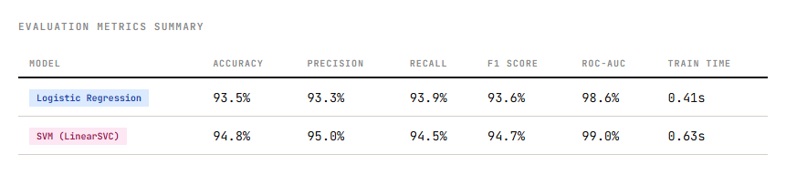

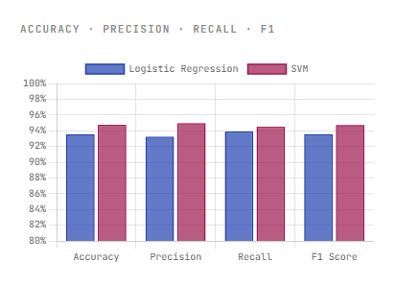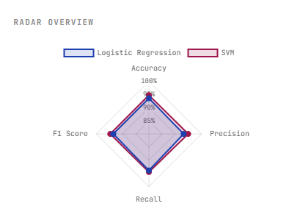
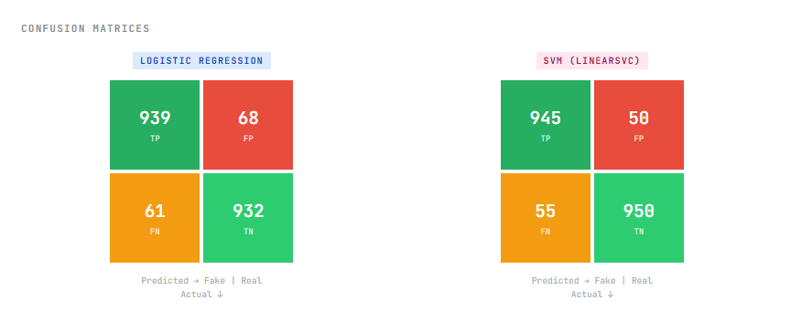

10. CONCLUSION AND FUTURE WORK
TruthLens successfully demonstrates the application of machine learning techniques for detecting fake news through a user-friendly web-based platform. By leveraging Logistic Regression and Support Vector Machine (SVM) models trained on a balanced dataset, the system is capable of accurately classifying news articles as real or fake. The project highlights the effectiveness of text preprocessing, TF-IDF feature extraction, and supervised learning algorithms in addressing the growing challenge of misinformation. Additionally, the browser-based implementation ensures accessibility, privacy, and ease of deployment without requiring external servers or APIs.
Although the current system achieves strong performance, several enhancements can further improve its capabilities:
- Utilize larger and more diverse datasets to improve generalization.
- Support multilingual fake news detection for broader applicability.
- Integrate advanced deep learning models such as LSTM, BERT, and RoBERTa for improved contextual understanding.
- Implement periodic dataset updates to adapt to evolving news patterns and reduce model drift.
- Expand detection capabilities to cover domains such as healthcare, finance, sports, and entertainment.
- Incorporate explainable AI techniques to provide insights into prediction decisions.
- Enable model persistence and optimization to reduce loading and retraining time.

11. GITHUB
https://github.com/SponsorSeagull/truthlens

12. LIVE DEMO LINK
https://sponsorseagull.github.io/truthlens/

